MUHAMMAD SAIF ULLAH KHAN
F2024332165
OS LAB TASK 03
BASIC CALCULATOR

CODE:

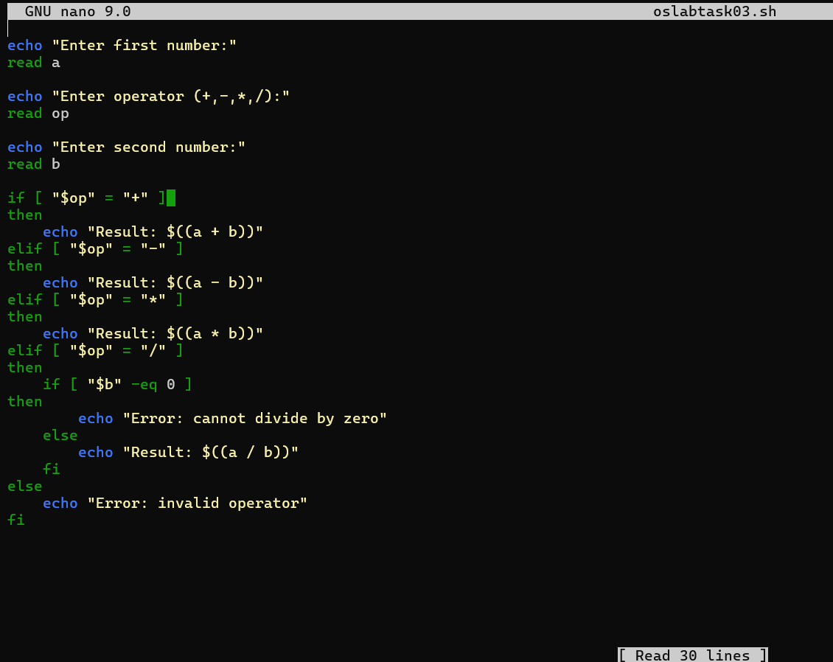
OUTPUT:
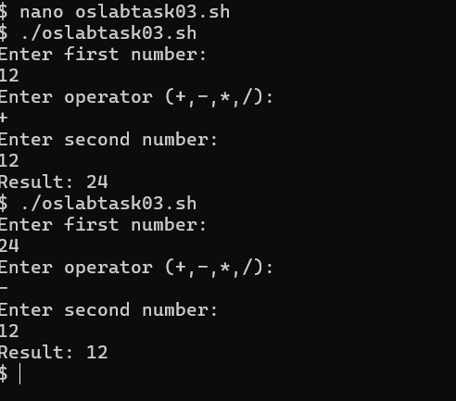

GITHUB REPOSITORY UPLOAD:

